Bosh BME280 TPH sensor

1. I²C Wiring

* Connect Vin to the power supply, 3-5V is fine. Use the same voltage that the microcontroller logic is based off of. For most Arduinos, that is 5V
* Connect GND to common power/data ground
* Connect the SCK pin to the I2C clock SCL pin on your Arduino. On an UNO & '328 based Arduino, this is also known as A5, on a Mega it is also known as digital 21 and on a Leonardo/Micro, digital 3
* Connect the SDI pin to the I2C data SDA pin on your Arduino. On an UNO & '328 based Arduino, this is also known as A4, on a Mega it is also known as digital 20 and on a Leonardo/Micro, digital 2

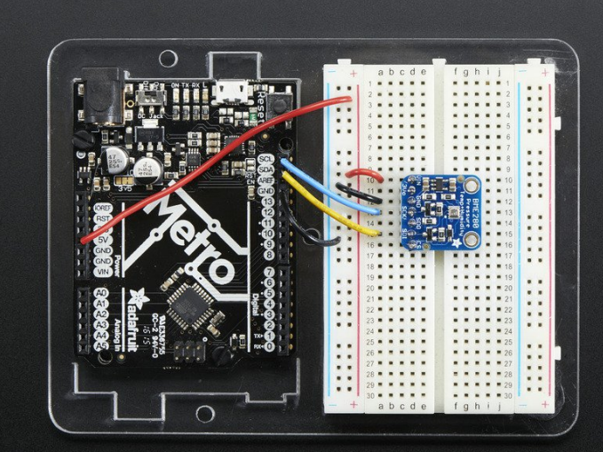

1. SPI Wiring

* Connect Vin to the power supply, 3V or 5V is fine. Use the same voltage that the microcontroller logic is based off of. For most Arduinos, that is 5V
* Connect GND to common power/data ground
* Connect the SCK pin to Digital #13 but any pin can be used later
* Connect the SDO pin to Digital #12 but any pin can be used later
* Connect the SDI pin to Digital #11 but any pin can be used later
* Connect the CS pin Digital #10 but any pin can be used later

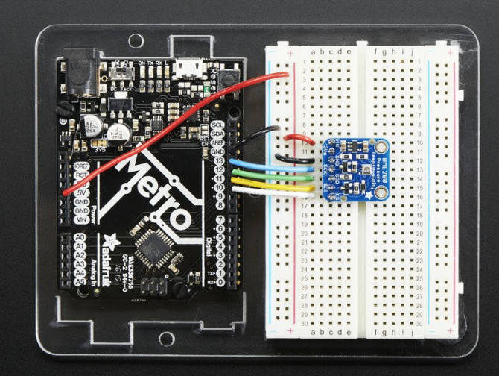

Particle sensor: SDSO11

* Deze sensor gebruikt UART
* Power requirement:
  + Power Voltage：4.7~5.3V
  + Power supply：>1W
  + Supply voltage ripple：<20mV
* Interface specifications

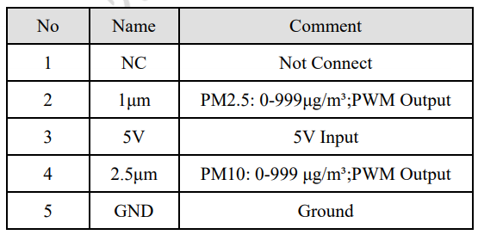

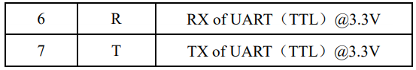

* The UART communication protocol
  + Bit rate ：9600
  + Data bit ：8
  + Parity bit：NO
  + Stop bit ：1
  + Data Packet frequency: 1Hz

